ECE356 lab3 part3

**Case 1.** No indexes

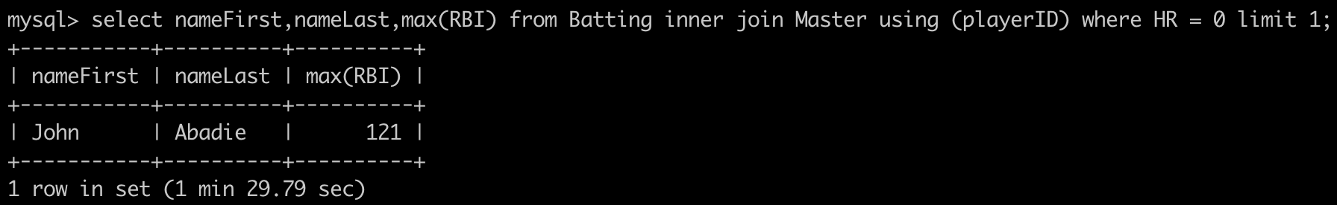

+----------+-------------------+-------------------+----------------+---------------------------+

| EVENT_ID | TIMER_START | TIMER_END | TIMER_WAIT | (TIMER_END - TIMER_START) |

+----------+-------------------+-------------------+----------------+---------------------------+

| 1809 | 79313915543000000 | 79403705617000000 | 89790074000000 | 89790074000000 |

query time = 89790074000000 ps = 89790074 us = 89.79 s

comment:

without any index, the query time is very long.

**Case 2.** Add playerID as primary key in Master table

ALTER TABLE Master

ADD CONSTRAINT `pk_Master` PRIMARY KEY (playerID);

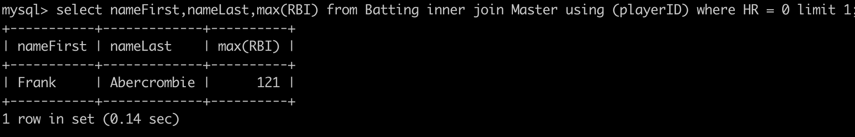

+----------+-------------------+-------------------+----------------+---------------------------+

| EVENT_ID | TIMER_START | TIMER_END | TIMER_WAIT | (TIMER_END - TIMER_START) |

+----------+-------------------+-------------------+----------------+---------------------------+

| 1958 | 79466265778000000 | 79466404694000000 | 138916000000 | 138916000000 |

query time = 138916000000 ps = 138916 us = 0.139s

comment:

Since playerID is used in the ‘using’ statement, we try to index playerID.

When playerID is added as the primary key of Master table, it is indexed.

The query time has dramatically decreased to 138916 us, by 99.85%.

However, the result of the select query gets a different name from last time. This is because the order of the results changed, and the ‘limit 1’ takes the top of the results.

**Case 3.** Add playerID as primary key in Master table, add playerID in Batting table as foreign key to Master table.

ALTER TABLE Master

ADD CONSTRAINT `pk_Master` PRIMARY KEY (playerID);

ALTER TABLE Batting

ADD CONSTRAINT `fk_Batting_Master` FOREIGN KEY (playerID) REFERENCES Master (playerID);

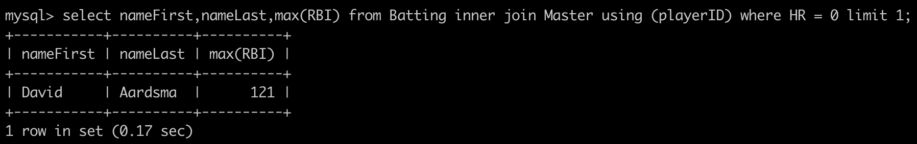

+----------+-------------------+-------------------+---------------+---------------------------+

| EVENT_ID | TIMER_START | TIMER_END | TIMER_WAIT | (TIMER_END - TIMER_START) |

+----------+-------------------+-------------------+---------------+---------------------------+

| 2109 | 80069672397000000 | 80069838815000000 | 166418000000 | 166418000000 |

query time = 166418000000 ps = 166418 us = 0.166 s

comment:

Since the batting table also has a playerID column, I tried to add a foreign key on it reference to the Master table. The query time has slightly increased to 166418 us, by 19.8%. The result of the name also changed, this is again due to the order issue.

**Case 4.** Add playerID as primary key in Master table, add playerID in Batting table as foreign key to Master table, add

ALTER TABLE Master

ADD CONSTRAINT `pk_Master` PRIMARY KEY (playerID);

ALTER TABLE Batting

ADD CONSTRAINT `fk_Batting_Master` FOREIGN KEY (playerID) REFERENCES Master (playerID);

CREATE INDEX IX_Batting_HR ON Batting(HR);

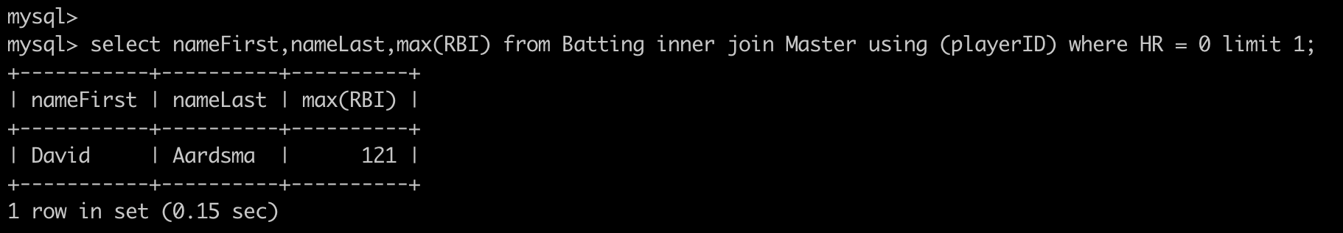

+----------+-------------------+-------------------+---------------+---------------------------+

| EVENT_ID | TIMER_START | TIMER_END | TIMER_WAIT | (TIMER_END - TIMER_START) |

+----------+-------------------+-------------------+---------------+---------------------------+

| 2117 | 81656701298000000 | 81656855197000000 | 153899000000 | 153899000000 |

query time = 153899000000 ps = 153899 us = 0.153s

comment:

Since the HR field is used in ‘where’ statement, create an index on it should help the query time. It has decreased to 153899 us, by 7.52%. It is a valid improvement by adding index on HR.